Editorial Comments (please reply point-by-point)

- Title page
- We added the Title page in your revised manuscript. Please confirm it is okay.
>>>Sure
- Please provide the special symbol * for the correspondence author.
>>>we have provided the special symbol * for Yuan Zhang
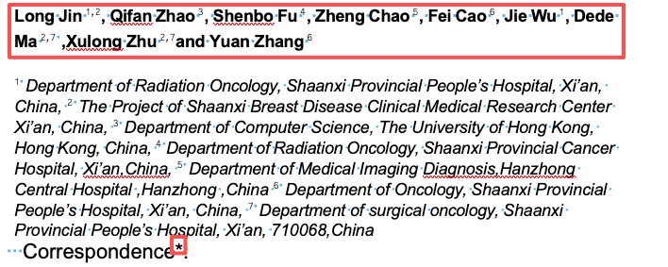
- Please provide a short Running title with no more than 60 characters (including spaces).
>>> We have added a short running title (≤60 characters) as requested:
“Explainable machine learning for M1 Breast Cancer Survival”
- Please rearrange the authors’ contributions in the following format.
Authors’ contributions
(I) Conception and design:
(II) Administrative support:
(III) Provision of study materials or patients:
(IV) Collection and assembly of data:
(V) Data analysis and interpretation:
(VI) Manuscript writing: All authors.
(VII)Final approval of manuscript: All authors.
−Note: VI and VII of All authors are obligatory while the rest information is case-based.
−Please fill in “None” for inapplicable items.
>>> We have changed the corresponding contribution.
- Highlight box
- >>> We added the Highlight box.
- For an Original Article, a Highlight box is needed to highly summarize the key findings, innovation, and potential implications of the study. Please provide a highlight box for your manuscript.
- No reference should be cited in the highlight box.
- All abbreviations should be defined when they first appear in the box.
- The box should be concise with no more than 250 words.
- Here is the template:
Key findings
- We developed and externally validated explainable machine learning (ML) survival models for patients with M1 (stage IV) breast cancer using large-scale population data.
- The deep learning model outperformed the Cox proportional hazards model in both internal and external validation.
- Breast cancer subtype, metastatic site, and surgery of the primary tumor were identified as the most influential prognostic factors.
- Surgery was associated with improved overall survival (OS) in patients with bone metastases, but not in those with brain, lung, or liver metastases.
What is known and what is new? (two paragraphs)
- What is known:
Survival outcomes in metastatic (M1) breast cancer are highly heterogeneous. Prior prognostic models, mainly based on traditional statistical methods, show limited predictive accuracy and often lack interpretability. The survival benefit of local surgery in stage IV breast cancer remains controversial, particularly across different metastatic patterns.
- What is new:
This study introduces an explainable ML–based survival prediction framework for M1 breast cancer that integrates clinicopathological features, treatment variables, and metastatic patterns. By applying Shapley value–based explainability, the model provides transparent global and individual-level interpretations of prognostic factors, enabling both accurate prediction and clinical insight into survival risk.
What is the implication, and what should change now?
- Explainable ML models may support individualized prognostic assessment and treatment decision-making in M1 breast cancer. The findings suggest that local surgery should be selectively considered for patients with bone metastases, particularly non–triple-negative subtypes, while avoiding unnecessary surgery in patients with visceral metastases. This approach promotes more precise and transparent clinical management of stage IV breast cancer.

- References
- Please check if any more references need to be added in the below sentence since you mentioned “Studies”, but only one reference was cited. If not, “studies” should be changed to “a study/a previous study”.
>>> I have changed it into “A real-world study shows”
- Do not use square brackets. In the text, references should be identified using numbers in round brackets with a space before in which they appear consecutively [e.g., “causing most BC deaths (1)”; “MIBC are greatly needed (6-8)”.
>>> We have revised the manuscript to replace all square-bracketed citations with numbered references in round brackets
- The number of citations cited in the text (29) does not match the number of references listed (25). Please check carefully and update the reference list to ensure consistency.
>>>sorry about the misunderstanding. I have modified it based on the comment.
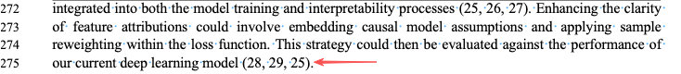

- Acknowledgments
- Please state whether there are any Acknowledgments to declare.
- If yes, please use the format “We would like to thank xxx for xxx” to express your Acknowledgements.
- If no, please indicate “None”.
>>>None

- Data Sharing Statement Form
>>>sorry about the misunderstanding. I have modified it based on the comment.
- Item 4: Please specify the documents names.
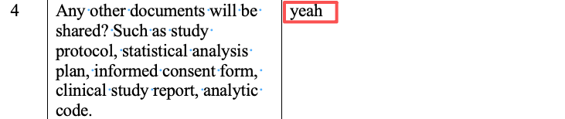
- The timelines in these two sections seem illogical, as the articles had not yet been published at that time and therefore could not involve data sharing. We recommend revising them to “from the publication date” and “within XXX (please specify a suitable time period).
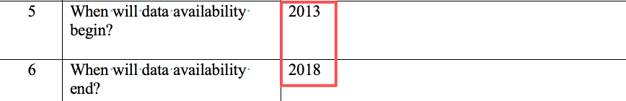

- Ethical statement
- Ethical statements have been edited as per our in-house format, please confirm.
>>>This looks good to me.
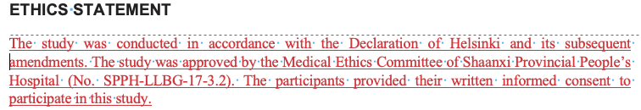
- Your Ethical approval number has been used in your previously published article (https://www.nature.com/articles/s41598-025-32375-2). Usually, one Ethical number can only be used in one study. Please kindly explain and provide the certificate of ethical approval to us.
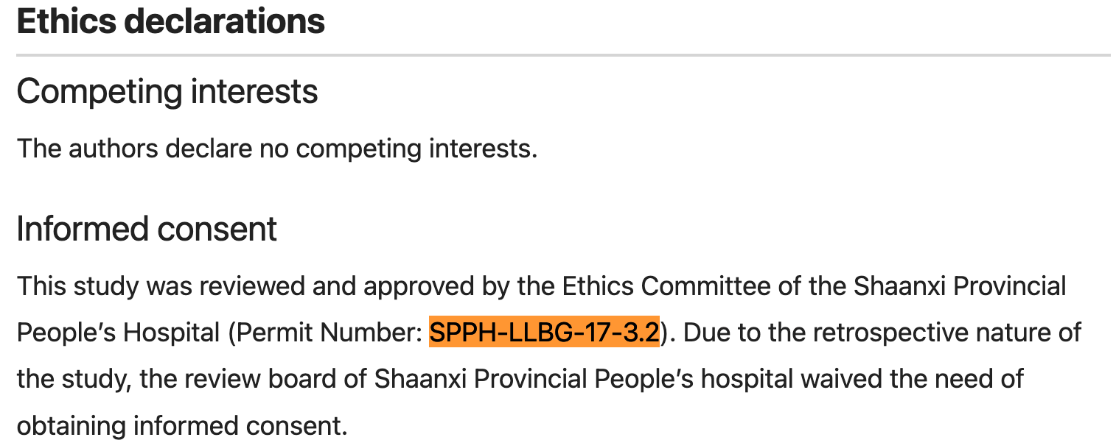

- Figures
- Do not insert Figures in the manuscript. Please remove them and kindly resubmit clear version of these figures as a separate file in JPG, TIFF or editable PDF format to us.
>>>I have offered it into the directory
- Please list Figure legends on a separate manuscript page after the references list.
>>>Done
- Figure 1:Please provide an editable version as a stand-alone doc/PPT file for copy-editing.
>>>I have offered it into the directory
- Figure 4: Please provide the summarized legend of Figure 4.
E.g., Figure 4. XXXXX. (A) xxxx; (B) xxxx; (C)xxxx. Abbreviations: xxx, xxx; xxx, xxx.
>>> I have changed it into “Figure 4. Overall survival comparison between surgery and non-surgery groups in metastatic subgroups after propensity score matching.
(A) Bone metastasis; (B) Brain metastasis; (C) Lung metastasis; (D) Liver metastasis.
Abbreviations: OS, overall survival.
”

- Tables
- Do not insert Tables in the main text. Please list all Tables on a separate manuscript page after the references list.
>>>we have finished it accordingly.

